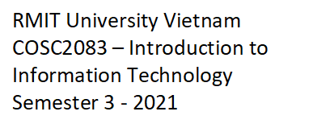

**ASSIGNMENT 2**

**THE IT WORLD**

**Group 5**

**Le Ngoc Duy s3757327**

**Hua Nam Huy s3881103**

**Nguyen Minh Quan s3729181**

**Nguyen Ngoc Duc Tri s3926650**

We declare that in submitting all work for this assessment we have read, understood and agree to the content and expectations of the Assessment declaration.

**Table of Contents**

**I.** **Team Profile** ( Nov 19 ) 3

A. Team Name: … 3

B. Personal Information 3

C. Team Profile 6

1. Myer-Briggs Test Results 6

2. Learning Style Test Results 8

3. Big Five Personality Test Results 10

4. Our thoughts about the test results 12

D. Ideal Jobs 13

**II.** **Tools** 14

**III.** **IT Work** 14

**IV.** **IT Technologies** 16

**V.** **Project Ideas** 25

**VI.** **Feedback** 25

**VII.** **References** 26

# **Team Profile** ( Nov 19 )

## Team Name: …

## Personal Information

**Nguyen Minh Quan :**

My name is Nguyen Minh Quan, my student information is s3927181 and s392718@rmit.edu.vn and I am currently a first-year student at RMIT University, studying Bachelor of Information Technology. I was born and raised in Ho Chi Minh City. My family has 4 people but now, it is only 3 since my older sister is working abroad. I am really into playing games and finding out special mechanisms to learn more about how things work in the technology industry. In my daily routine, I usually play games in my free time. It is a good way for me to communicate with my old friends as we are in different schools now. After a hard-working day, there is nothing better than having fun with your mates. Besides, sitting in front of technological gadgets all the time is not good, that is why sometimes I go to the coffee store to hang out and meet people face to face. That is extremely great and feel at ease. About my IT interest, the first game that I played was Eden Eternal when I was 7 years old. However, my young age can not stop me from enthusiast games. From that moment, I played a lot of different games such as MOBA, Gacha, MMO. To me, games are not only for relaxing but also for training our soft skills and strategies that we can apply in real-life situations. Talking about my experience in the Information Technology field, I haven’t had much since I just started learning recently. Most of my knowledge is about Python and a bit of using terminals such as Git Bash or Shell.

**Hua Nam Huy :**

My name is Hua Nam Huy. My student number and email are s3881103 and s3881103@rmit.edu.vn, I come from Ho Chi Minh City, Vietnam, and have been studying Software Engineering at RMIT University on Saigon South Campus for 3 semesters. Playing video games with my pals, watching YouTube, and reading light novels are some of the things I enjoy doing in my spare time. When I was a child, my grandfather owned a PC that he used for business. The computer didn’t have anything fancy except basic office software like Microsoft Word, Excel, and PowerPoint to aid my grandpa with his profession as an attorney but he did install some games on it for entertainment so I often used to ask my grandpa for permission to play those games whenever he isn’t using the computer. In those days, I aspired to be a video game creator as I was captivated by games, but the advent of the Internet and social media altered everything. Following that, I learned that the field of information technology encompassed more than just games, and I developed an interest in learning more about IT and its applications in our world. I was curious as to how IT technicians and programmers made it so that whatever information you want to know is available at the click of a button, or how they managed to create a video game with moving characters and sound. This inspired my decision to become a software engineer and discover how the world of IT works through the use of lines of code. I've only had a little experience with programming languages like Python and C/C++ up until now, and as I finish my first year at RMIT University, I intend to enroll in additional courses to get more programming knowledge and expertise. I'd like to learn more about the Java and Python programming languages to help with my coding studies, as well as becoming acquainted with key software engineering ideas, patterns, and tools that would be required for any career requirements.

**Nguyen Ngoc Duc Tri :**

My name is Nguyen Ngoc Duc Tri. You can find me with my student ID: s3926650 or my email address: s3926650@rmit.edu.vn. I was born in Ho Chi Minh City on September 17th, 2003, which means I’m 18 years old now. I’ve been learning English non-stop for the past 12 academic years and recently, I’m studying Chinese to expand my language skills, as well as getting to know more about the Chinese culture. I think I’m the kind of person that is always motivated to dig deeper into things that are new to me, or what I love to do, such as coding, technology, which has then led me to the world of IT. I enjoy playing sports like badminton and ping pong, yet due to my eye issues, I’m not allowed to play sports anymore, which frustrated me a lot. I love playing video games, however, I’m also very interested in how the games are made since the first time I played them, which aroused my dream of becoming a Game Developer. When I first played video games, I realized that not only did I want to play them, but I would like to make a game of my own too. Therefore, I started to research how a game is made. There are many elements, but one of them had sparked up my interest in IT: Coding and programming languages like C++, Javascript, C#, etc. Until now, I’ve learned through the basics of Pascal, C++, HTML, CSS, Javascript, and Python. In addition to the valuable lectures and tutorials throughout the courses, I expect to improve and gain more experience in teamwork, programming logic, knowledge in IT, as well as making new friends, seeking chances to interact with professional IT experts and learn as much as I could from them.

**Le Ngoc Duy :**

My name is Le Ngoc Duy, my student number s3757327, and my email address is s3757327@rmit.edu.vn. I was born and raised in Ho Chi Minh City, Vietnam. The diversity in the culture of our nation has always been an interest of mine. I love to travel, explore new places, meet new people, and learn new things. Apart from that, I enjoy exercising in my free time. My first interests in IT began when I was a young kid. When I was younger, I played a lot of games on the computers at home. While I was playing them, I could not help but wonder how all of this works. Questions like how such a small device can contain so many things, and how we can do so much with computers were also sparked my interest. Along with playing video games, I frequently watched the TV as a kid. There were many channels that broadcasted movies and documentaries which showcased the power of computers and programmers, moreover, they also showed how programs were being used for manufacturing lines that implemented automation technologies. Those were the starting point that set me of on this journey. I expect to have a strong core knowledge of IT in all aspects such as coding skills, problem analysis, problem solving, teamwork, time management, handling conflicts, etc. During the time of my studies, I would also like to enjoy an abundance of extracurricular activities that RMIT is providing. One of which being the vast number of clubs that are operating within RMIT. This will give me the opportunity to make new friends and further broaden my knowledge beyond my major.

## Team Profile

### Myer-Briggs Test Results

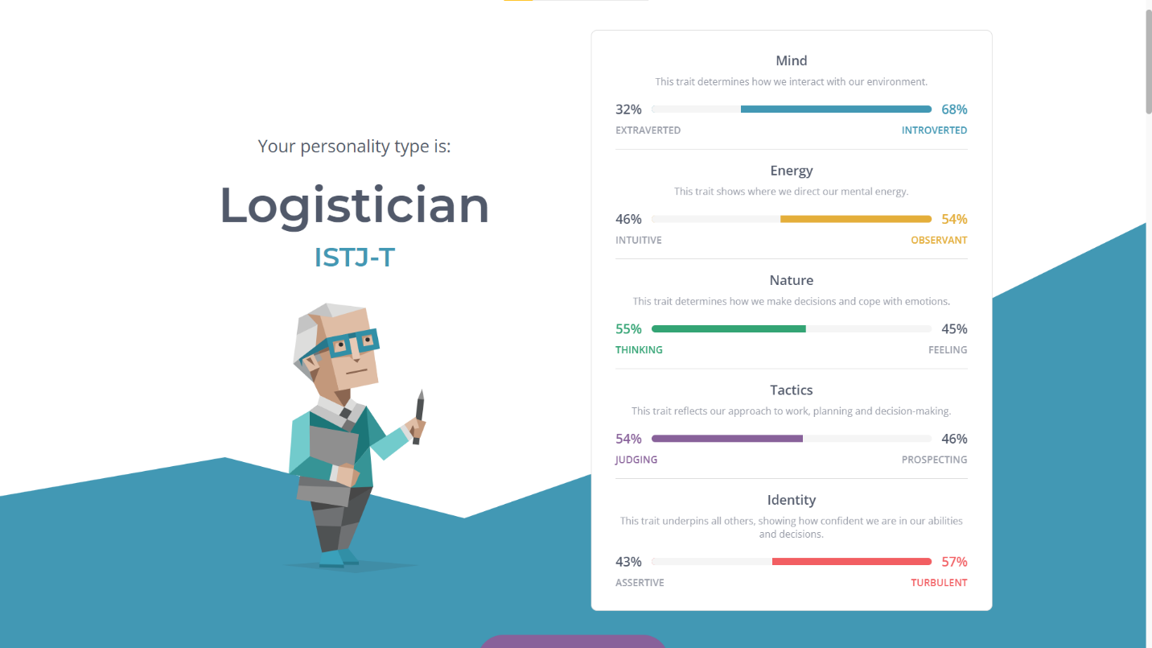Quan: <https://www.16personalities.com/profiles/7c6b2c2ff6a89>

Huy: [Introduction | Advocate (INFJ) Personality | 16Personalities](https://www.16personalities.com/infj-personality)

Tri: <https://www.16personalities.com/infp-personality>

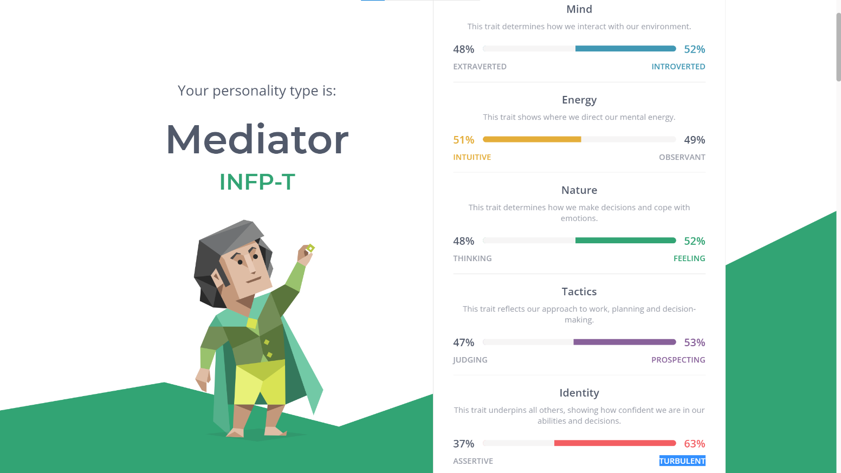

Duy: <https://www.16personalities.com/enfj-personality>

### Learning Style Test Results

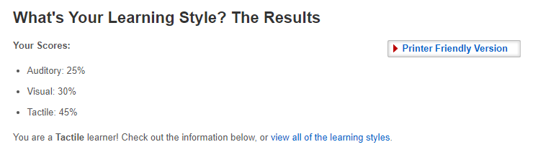Quan: <http://www.educationplanner.org/students/self-assessments/learning-styles-quiz.shtml?event=results&A=5&V=6&T=9>

Huy: [What's Your Learning Style? The Results (educationplanner.org)](http://www.educationplanner.org/students/self-assessments/learning-styles-quiz.shtml?event=results&A=9&V=8&T=3)

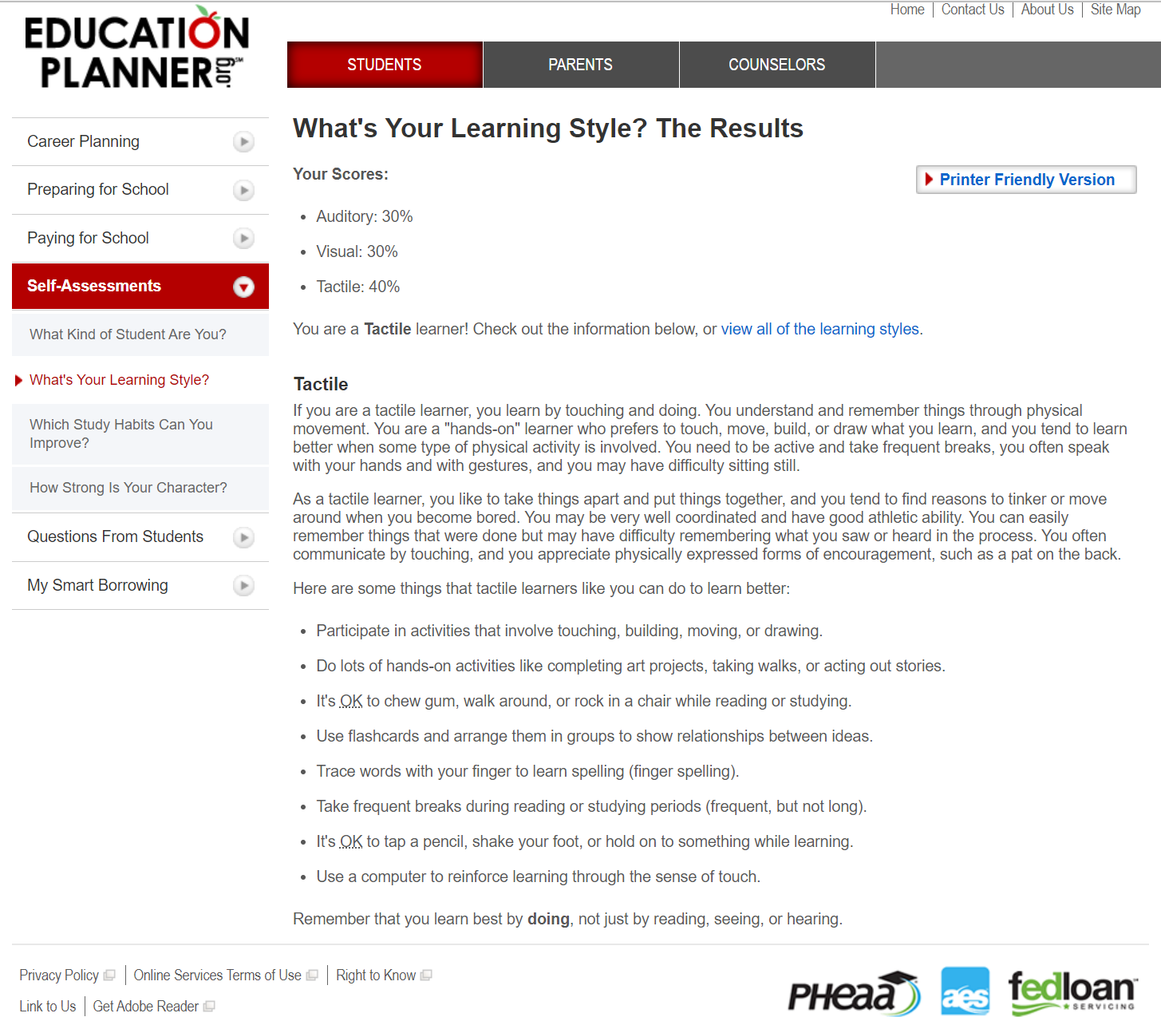Tri: <http://www.educationplanner.org/students/self-assessments/learning-styles-quiz.shtml?event=results&A=6&V=6&T=8>

### Big Five Personality Test Results

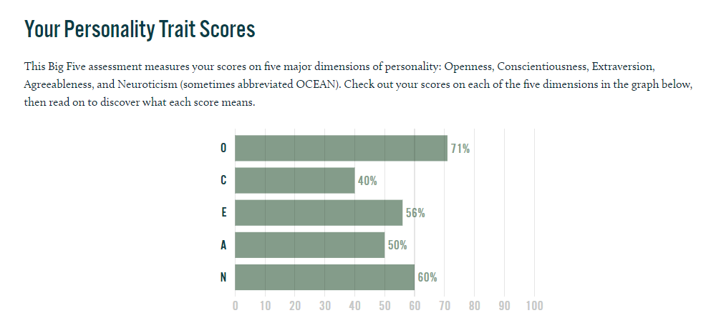Quan : <https://www.truity.com/test-results/bigfive/17315/22950904>

Huy: [The Big Five Personality Test | Truity](https://www.truity.com/test-results/bigfive/17315/22868216)

Tri: [Free Big Five Personality Test - Accurate scores of your personality traits (truity.com)](https://www.truity.com/test/big-five-personality-test)

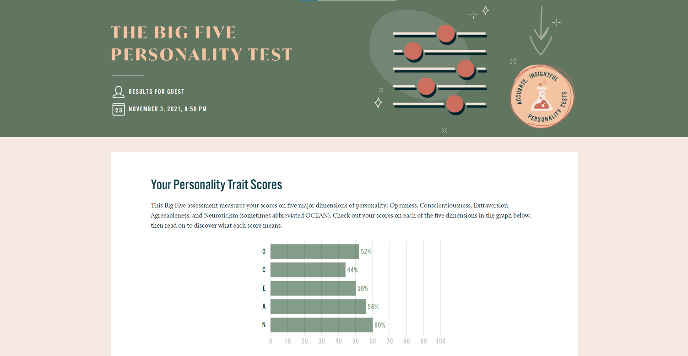

Duy: <https://bigfive-test.com/result/618f6ad06fb747000995d40e>

### Our thoughts about the test results

**Nguyen Minh Quan :**

The tests indicate impressively true about me. Firstly, the Myer-Briggs test tells me that I am a logistician, which means that I can evaluate situations based on reality and the surrounding environment and there should not be emotional judgings. This can really help when my team needs to decide choices. Secondly, the Big Five test shows me that I am an open person while in a team since my Openness and Agreeable rates are high. I think that in a team, I will be the one who connects everyone together and solve conflicts. However, my weakness is Neuroticism, this percentage is high compares to other people who do the test so I assume that I will try to calm myself and try to be relaxed as much as possible so that my negative aura will not affect my team. Lastly, the learning test says that I am a tactile learner, which means that I have to practice a lot to master something. In my opinion, this trait at first will not have much value since I do not have any mastered skills or knowledge, but the longer I work or learn things, the greater outcome that I can make and contribute to my team.

**Hua Nam Huy :**

I believe the tests are mainly true in terms of my personality, how I respond in social situations, and my learning style. The results revealed my strengths and faults, as well as recommendations for how to fix my flaws. While the test results may define me as an introverted person who prefers to tackle things on my own, I don't feel it would have much of an impact on my conduct because when you're part of a team, you must give your best and be a responsible teammate for the group to work properly. So, when building a team, I'd look for teammates with abilities and expertise that could compensate me for what I'm now lacking, and in turn, I'd aid my teammates with their problems by filling in for them utilizing my strengths. To that end, I'm always prepared to complete my task to the best of my ability, to listen to others for advice on how to fix my mistakes, and to use my strengths whenever they're needed to help the team.

**Nguyen Ngoc Duc Tri :**

For me, the results of these tests reflect my personality, and my attitude when dealing with certain situations. However, not everything in these test results is correct about me. For example, I actually think a lot before doing something rather than just doing it emotionally. Therefore, I don’t see them as my actual person. On the other hand, some factors truly show what I am right now, and I appreciated having recognized them. As can be seen from the result, I’m an introverted person, and for me, this is not good at all when forming a team. Since I feel uncomfortable communicating with other teammates, it would be annoying and reduce the whole team’s productivity and outcomes in some worse scenarios. I’ll carefully take a look at myself again, and then try my best to improve, especially my communication and group-working skills.

**Le Ngoc Duy :**

The results from the three tests above provided a very interesting view of my personality and preferences that even I am not aware of. they give accurate suggestions for me to make better decisions career-wise Moreover, I get to know my strengths and weaknesses better so that I can plan my studies accordingly to maximize my strengths and improve my weaknesses. Given the results that I received, I know what kinds of behavior and action can be beneficial to the team, in terms of increasing efficiency, performance. But I would say that it will not greatly influence my behavior because I will likely be true to myself and express my truest self to others.

## Ideal Jobs

After we read and discussed each ideal job, we were surprised because we had bunches of common elements in our future careers. First of all, our positions use most of the knowledge related to Information Technology to understand and implement it. We can take advantage of our understanding of the Information Technology aspect to cope with issues during the work of our jobs and work more fluently in the corresponding position. Next, through the IT field is vast and ever-changing, it is clear to see that on the way to achieving our roles, we may have some general principles, programming patterns, and concepts. We all have to go on the same first path of learning basic knowledge in software development such as coding, testing, or taking feedback from users, and maybe we also need to master some languages other than our mother tongue. Besides, in any field, teamwork is extremely significant as it helps us to have a better understanding between clients, or teammates, leading to the improvement of our products, or even expansion of social relationships.

On the other hand, there are many ways to distinguish our positions because of the contrast in our logical thinking skill, way we approach the ideas or even the intended uses.  In the game aspect, Quan plans to be the game director in Riot company, which will have much more requirements and responsibilities to deal with while Tri wants to work in one of the most popular game engines Unity. Every company has its strategy in working methods or attracting customers, so there are many different problems that both of them may encounter. With Huy’s future career, he desires to be a Software Engineer. Because of that, he needs to work in other working environments, use various range of knowledge to manage his job such as using Linux, the Internet of Things, etc. Lastly, Duy hopes that in the future, he can work as a mobile developer. This can be about smartphones, android, IOS, etc so he may need to dig deeper about this facet in order to master it. Moreover, it is easy to see that in the game industry, individuals must have incredible imagination or a deep understanding of games’ mechanisms. Meanwhile, Huy may need to develop his fluency in the corresponding job such as HMI, Internet of Things, Machine Learning. The unstoppable rise of cellphones does not have any sign of slowing so Duy can take advantage of this to acknowledge mobile development.

# **Tools**

…

# **IT Work**

[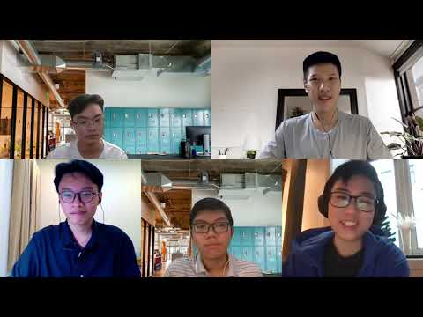](https://www.youtube.com/embed/iRJyYF-P3Ko?feature=oembed)

<https://youtu.be/iRJyYF-P3Ko>

These answers are extracted and modified according to the video.

1. **What kind of work is done by the IT professional?**

Ms. Thao Nguyen is currently employed as a software engineer at a Norwegian IT firm, where she develops software and infrastructure for the company utilizing Amazon Web Services. She also develops and tests features for her company's web dashboard, as well as new Application Programming Interfaces (APIs) and client-facing features for the corporate website. Her job also involves engaging with the company's product team to keep them up to date on the product development process so that they may inform customers of the current product status.

1. **What kinds of people does the IT professional interact with? Are they other IT professionals? Clients? Investors? The general public?**

During her working time, Ms. Thao Nguyen has many interactions with a handful of different personnel. The first interaction she mentioned was with her colleagues. During the product development process, a lot needed to be discussed within the team. Then, she shared that interaction with clients was also important because the team needed to ensure the correctness of the product before shipping them out to their customers.

1. **Where do the IT professionals spend most of their time?**

Ms. Thao Nguyen works in a Norwegian office. COVID-19, on the other hand, made her work from home for a long period, and she occasionally took online meetings with clients, investors or colleagues and bosses. Up until several months ago, when the pandemic situation in Norway got better, her company began to return to office as soon as possible.

1. **What aspect of their position is most challenging?**

The most difficult issue for the IT expert seems to be the way they implement and apply their product. For example, when the client asks the expert to create a new feature, there are countless way to achieve that so the professional has to confirm it again with the client to work on the right path. It takes a lot of trials, errors, and meetings with the team to complete the final product. Sometimes, the customer wants to change the content so the IT expert have to think and try to avoid run-time errors as well.

# **IT Technologies**

**Quan – Artificial Intelligence and Machine Learning**

1. Capacity of AI and Machine Learning
   1. The current standing of AI and Machine Learning.

In this ever-changing world, technology has become something indispensable to our daily routine. They are present in every aspect of life, from doing house chores, learning at school to controlling Big Data, exploring space, and manipulating important chemical reactions. Artificial Intelligence and Machine Learning are some of the main platforms for those innovations and developments. Until this moment, AI and Machine Learning have had a remarkable position in the IT industry. The appearance of the robot Sophia or many virtual assistants is the clearest proof of the power of Artificial Intelligence and Machine Learning at the moment. There is no doubt about the current position of AI and Machine Learning, Helbert Simon once said that “Machines will be capable, within twenty years of doing any work that a man can do “ [1].

* 1. Possible things that AI and Machine Learning can do.

Nowadays, we can easily see trails of AI and advanced Machine Learning around us. For example, in our daily life such as “Smart House”, where everything can be controlled by voice and there are no switches inside the house. Moreover, in heavy industry, AI appears as a helpful assistant to help humanity. When merging with quantum computers and advanced technology methods, those pieces of machinery have a significant reduction in energy usage and an incredible data processing speed [2]. They are used for great purposes. For instance, forecasting the weather conditions by those computers can be done not only for a few days or a few weeks but also for years, which are totally useful for people to cope with natural disasters. Moreover, especially in medical fields, quantum computers can mimic the movements and the statuses of atoms [3] so that many scientists can do research and reach the final solution in a short amount of time.

* 1. Ideas that can be launched in the near future.

Talking about the near future, there are many things that we can discuss. Firstly, the metaverse is the breakthrough that must be mentioned. Recently, Mark Zuckerberg - CEO of Facebook, announced to us about the development of a virtual world, where everyone can see their friends no matter distance. It is a leap not only in IT in general but also in business because of its convenience and optimization. Secondly, more and more crucial tasks can be done by machines such as firefighting and exploring space. When doing these jobs, we can only equip ourselves with limited knowledge and pieces of equipment, but robots are not the same, they can learn a trillion books in a week, cool down their systems near to the absolute zero, or even be capable of handling and transporting deadly liquids. [4]

* 1. Tools and developments can actualize these evolutions.

In my point of view, the most crucial factor is humanity’s perspectives on AI and Machine Learning. If we have good intentions and carefulness, our products will be fruitful and do proper things. Otherwise, people with the aim of corrupted motives, their work can be a threat to society. This is particularly true when talking about Bob and Alice, both are AI robots, designed by Facebook AI Research. However, we have to put a stop to both of them because of their mysterious behaviors, which form their own language to communicate with each other. That is a lesson for everyone doing related fields, we should control our programs more strictly, limit the source or the method that can be a risk to our artifact.

The technological aspect seems to be less nasty, the more research we fail, the more modern our technology will be. So, when it comes to technical issues related to high-risk jobs, which are mentioned above. One possible solution is to build a simulator combined with AI and Machine Learning. As mentioned above, firefighting, space exploring, and more require us to have practical experience. AI and Machine Learning can create potential simulators for those jobs so we will be able to use a simulator to train our ability.

1. The impact of AI and Machine Learning
   1. ​Potential impacts that can be made.

Initially, during this Covid-19 pandemic, we all find it difficult to communicate with each other directly and many disadvantages in many aspects such as learning, working in the industry, and doing business. Thanks to AI and Machine Learning, these troubles seem to be solved. With technologies, we can do everything without face-to-face connection, which leads to the reduction of virus spreading. Secondly, as mentioned above, we can cut down huge amounts of working positions in dangerous jobs like firefighting, interactions with nuclear power, or exploring university leading to the reduction of the hidden risks ratio and lessening the number of fatal accidents during works. Moreover, machines are capable of absorbing data faster than humans so they will make jobs simpler.

* 1. Changes that can happen in the future.

Expansions move together with varieties, and we cannot avoid them. In my opinion, the most changing aspect should be the way humans interact with machines. Especially in transportation, it may lose its current standing when the world is going to connect through a sci-fi world, meetings, excursions, are all going to be held online. We have no idea whether those are positive or negative changes, but we cannot deny that they bring significant changes to us. Besides, cybersecurity should also be mentioned. In recent years, organizations have always tried to overstep hackers in order to protect their data. With the rise of Artificial Intelligence and Machine Learning, the protections can be stronger than ever using face recognition or fingerprints. [5]

* 1. Most affected people, and the change of AI can do with humanity

The highly influenced people seem to be businesspeople. Imagine that instead of noting down each of your schedules and keeping track on your own every time, now we just have to use an AI assistant to help us address all the information and save bunches of time. Furthermore, people’s place in many fields such as manual workers can also be taken over by machines. On the good side, we can take advantage of robots’ power to make jobs painless. However, the division between the rich and the poor is likely to increase due to this.

1. My life when AI and Machine Learning appeared.
   1. ​AI and Machine Learning changed the way I lived and so did my relationships.

In my daily routine, AI and Machine Learning help me to have a better lifestyle. For example, I can control the nutritious meals that I eat, I do everything in time because I have an online reminder assistant and I am able to save more time because I have automatic gadgets such as vacuum cleaners or washing machines. To me, as a student of Information Technology, the most changed thing is the way I study. With today’s technology, it is not hard for me to find an AI teacher online such as Google AI, and then look for my lesson. Besides, rather than spending time looking for informative books at the bookstore, search engines with advanced AI can help me to quickly extract my findings, resulting in a better outcome. It not only saves a lot of time but also is extremely flexible so I can match it up with my learning schedule at school. About my surrounding relationships, I find that AI is actually helpful. My parents cannot go outside during this Covid-19 pandemic, and they are not familiar with using online shopping platforms, but they are still able to book foods and vegetables because of the AI voice assistant, this is rarely popular back to 10 or 15 years ago. My friends are mostly the same age as me so we do not have to worry about buying commodities but through advanced AI and Machine Learning technology, we can keep in touch with each other. For example, if we want to set up an offline meeting, everyone in my group can use Google Map to know the directions and is unable to get lost. Those are the clearest proofs of what AI and Machine Learning can affect our daily life until this moment. I hope that in the future, we can upgrade these technologies to a new level and form a beautiful hi-tech world, where AI can do most of the things and we just need to keep it under our supervision.

**Huy – Cybersecurity and Privacy**

* **What does it do?** ​
  + What is the state of the art of this new technology?

Cybersecurity-related topics are now making news across the media and a variety of settings, including businesses, online blogs, and social media platforms, causing many scandals, and reminding the world of the importance of information security. Examples can be seen in 2018 when it was revealed that the data analytics firm Cambridge Analytica unlawfully harvested data from tens of millions of Facebook users for ad targeting during the 2016 United States presidential election [6] or in June of 2021 when the professional networking service LinkedIn reported that data including personal information of nearly 700 million of its users were stolen by a hacker and posted on a dark web forum [7]. As time goes by, people, networks, and governments all across the globe has become more and more reliant on the Internet and social media platforms for their day-to-day activities, thanks to the Internet's global connectivity and its presence in everything we do from communication, business, education to entertainment. Due to that, cybersecurity has become increasingly important in the operations of businesses and people when using the web in order to deal with the increasing threats from the cyber world. Cybersecurity, as an inherent component of computer science, is the use of techniques and procedures to safeguard computer systems, networks, internet-connected devices, and software against cyberthreats such as ransomware, malware, phishing, denial-of-service attacks, and more methods, preventing them from accessing databases and important systems for malicious purposes [8]. Some of the most recent cybersecurity technologies are the implementation of AI and Machine Learning to analyze large amounts of data and using behavioral analytics to aid in the detection of potential and real-time cyber threats by identifying unusual patterns in a system's and network's actions [9]. Blockchain cybersecurity, which operates on the peer-to-peer network basics of blockchain technology and verifies user activity while employing encryption to safeguard the user's data from illegal access, is another technology that is also getting traction and recognition from IT professionals. [9].

* + What can be done now?

Current security methods range from simple passwords, firewalls, backing up data and antivirus software to more advanced systems such as biometric recognition, which identifies a person based on their biological and behavioral characteristics such as a fingerprint, iris, retina, hand shape, voice, and signature [8] along with enabling multi-factor authentication (MFA) that would combine biometrics, text messages, emails and time-limited security codes for verification as a second layer of protection [10]. In addition, another important aspect of today’s cybersecurity is the implementation of information security protocols and policies together with the training of personnel to raise awareness about cybersecurity and reduce human error in incidents. Education of users and employees of basic information security principles such as safe surfing, identifying and dealing with cyber threats, securing, and backing up data along with risk management [11] is widely carried out by businesses and organizations around the world today as an integral part of their policies in order to maintain information security and protect their user’s data and operations from cyberattacks.

* + What is likely to be able to do be done soon (say in the next 3 years)? What technological or other developments make this possible?

The Fourth Industrial Revolution, often known as Industry 4.0, has resulted in increased interconnectedness and automation across the world. In the industrial sector, traditional production processes and old technologies are steadily being replaced by newer technologies such as smart gadgets, automated machines and more advanced computer systems which have helped improve the effectiveness and productivity of production in factories [12]. As more sectors and businesses are becoming “smart” and digitally connected through the Internet of Things (IoT), they also make themselves more susceptible to cyberthreats due to the lack of security in computer systems and devices along with the large shortages of skilled people in cybersecurity [12]. To deal with this worsening cybersecurity landscape, many technologies have been considered to be crucial in the upcoming fight against these looming threats. Cloud computing, which is a technology that has been around since the 2000s will prove to be important in defeating ransomware and malware as the cloud can employ big data and rapid analytics to preemptively identify and handle threats that attempt to overwhelm and bypass security to attack users [13]. In addition, automated technologies such as Artificial Intelligence (AI) and Machine Learning (ML) will continue to play a vital role in tackling Industry 4.0 problems in the future since the amount of internet-connected systems and digital devices are increasing to a point that traditional security methods cannot protect them all. This is where AI comes into play as it can process an enormous amount of data along with constantly monitoring online traffic and data for any hidden threats that would normally be too overwhelming for a human professional to handle [14]. Furthermore, by using algorithms to analyze user behavior and activities, detect unusual patterns, and dynamically handle cyber threats that are constantly changing, predictive algorithms and machine learning techniques will assist organizations in identifying and fixing vulnerabilities in their systems early to prevent data loss and disruption of the supply chain [15].

* **What is the likely impact?** ​
  + What is the potential impact of this development?

The Internet of Things is becoming increasingly important in both industries and our everyday lives. It’s present in every facet of human life from communication to business, education, healthcare, and government with the amount of IoT devices recorded growing every year. As a result, the amount of data that is generated and needs to be processed has also exponentially increased along with the frequency of cyberattacks. As cybersecurity plays a vital role in protecting the data of governments, organizations, military and socially critical infrastructure like finance and healthcare, we will see it being the focal point of future development. The adaptation of AI and Machine Learning will help businesses and industries automate data analysis, classify, filter, and handle large data chunks more efficiently than ever before. However, their implementation would also create new risks as those systems themselves may become under attack by hackers through corruption and also be used to create smart malware that is capable of bypassing security software. This in turn will drive businesses and organizations to facilitate the training of cybersecurity skills and education of information security in people to produce qualified IT professionals that would fill in the current shortage of skilled workers around the world.

* + What is likely to change? Which people will be most affected and how? Will this create, replace, or make redundant any current jobs or technologies?

Ever since people first discovered how to hack computer systems and networks, there has been an ongoing battle between cybersecurity professionals and cyberthreats. Development in IT technologies will undoubtedly help both sides to expand and find new strategies to outperform the other in the coming years [16]. The threat landscape will see major changes as hackers would also take advantage of Artificial Intelligence, Machine Learning along with new advanced tools and software to develop more sophisticated, dangerous malware that will be capable of corrupting automated systems and infiltrating the internal systems of organizations, stealing data, and disrupting critical operations. Ultimately, the ones that would be affected the most from this will be normal people like us who use the Internet in our daily lives as cyber attacks would cause major disruption to social infrastructures that we rely on like healthcare, power supply, education, communication, and transportation. Examples of this would be when there’s an emergency call and the hospital is unable to respond to the call due to their communication line being interrupted by hackers or even worse, endangering the lives of patients whose life support systems are turned off due to power outages from these attacks. Lastly, future developments in technologies would also see legacy machinery and old computer systems be eventually phased out as well as automation being more common in industries, reducing the number of cybersecurity professionals in some areas as future AI-based systems can help predict threats and handle complex situations more efficiently and less prone to errors.

* **How will this affect you?**
* ​In your daily life, how will this affect you? What will be different for you? How might this affect members of your family or your friends?

**Advances in cybersecurity technologies will have a wide range of consequences for everyone, including me. As new security methods emerge, I'll have to update my computer to stay up to date with the most recent antivirus software or security measures since hackers will eventually develop new malware and tools that are capable of bypassing and defeating current information security technologies. In addition, I would have to do checks more often on my current email and social media accounts in order to update their passwords as not changing your password for a long time will put your devices at risk of being attacked by cybercriminals. Furthermore, these threats will also remind me to be more careful when surfing the web and using social media platforms since malicious links and fake websites can now disguise themselves so they can steal your personal information without you even realizing it if you accidentally clicked on them. Furthermore, my parents would be needing my assistance because they were born before computers were invented and thus have little experience with the Internet and cybersecurity in general. As a result, it would be my responsibility to instruct them on safe web browsing behaviors and how to create strong passwords to protect my parents from cyber threats that seek to harm them on the Internet.**

**Tri – Blockchain and Cryptocurrencies**

…

**Duy – Autonomous Vehicles**

* **What does it do?**
* What is the state of the art of this new technology?

Autonomous Vehicles or AV in short, are receiving a substantial amount of development within the recent years. Many experts have predicted the rise of AV in the future [6]. They are vehicles that possess the ability to operate itself, based on the condition of the surrounding environment without any amount of human interaction. In order to perform such an advanced task, AV need an effective way of collecting and capturing data of the surrounding environment. Along with that, they need an adequete controlling program to handle collected data in order to make the correct controlling decisions.

There is a variety of methods that enables AV to gather necessary data, each with their own strenghths and weaknesses, and used for different purposes. These data can be generally called sensory input. Sensory input can be reccorded in many ways, from many different perspectives and positions. The most common approaches to collect these data are: radar, sonar, camera, and LiDar. These sensors and devices work dependantly or independantly to provide information which is used to determine whether there are any obsticles in close proximity of the vehicle, whether the vehicle is following a correct direction or path, and define the meaning of traffic signals and traffic signs.

The most vivid implementation of AV that customers can actually use is the service that a company named Waymo are providing. They have deployed a robo-taxi service in California, with a fleet of 100 self-driving minivans [7]. As the technological and engieering field tend to have standards for virtually everything, The Society of Automotive Engineers (SAE) has defined a standard for different levels of automated driving. This is a six-level scale, ranging from level 0 to 5, with 0 meaning no automation and 5 meaning full automation [8].

* What can be done now?

As AV are still during their intesnive development stage, a lot need to be done at the moment, especially from the technical standpoint. The first major thing that need to be done is developing more effective, and especially more accurate sensors or any form of data collecting and data capturing, as this is extremely vital for the safety of passengers riding on these autonomous vehicles. There has been cases that a AV failed to correctly handle a situation, with the most infamous case being the situation that a Tesla vehicle crashed into an overturned trucked in the state of California, USA [9]. Many problems are ultimately boilded down to the fact that a controlling unit failed to exactly determine the obsticle that is facing the vehicle. Problems relating to the conditions of the road, weather and traffic also require an intensive attention in order to increase the reliability of AVs.

* What is likely to be able to do be done soon (say in the next 3 years)?

In the future, developers can work out solutions for the remaining challenges that AVs will face in the practical condition. One of which is the interaction with passengers or riders. Traditionally, in a human operated vehicle, espeacially cars, drivers can make customized changes in the way he or she controls the vehicle based on their personal preferences or even emotions and physical conditions. This could be instances where a driver can decide to drive in a more calm manner to make the ride more relaxing and enjoyable, or drive a bit faster but still within the speed limit in order to save some time. As mentioned, not only drivers but passengers can also request the driver to drive or stop a certain way to match their preferences. In the future, AVs need to be able to handle this. Futhermore, developers and manufacturers can create an inter-connected network of AVs which allows them quickly communicate with eachother, thereby enabling better traffic related decisions to be made in order to improve travelling time by reducing chances of congestions.

* **What is the likely impact?**
* What is the potential impact of this development?

The development and implementation of AVs can have many impatcs, both positive and negative. With AVs being widely used, traffic and traveling as a whole will become more efficient and safer. Some of these benefits are:

* Reduced traffic accidents. As AVs are fully equiped with sensors which allow them to autonomously detect and predict collision, active safety systems like emergency breaking will defenitely help reduce the chances of accidents.
* Reduced congestion. Once AVs can communicate with eachother, coupled with the network of AVs which can be used to measure real-time traffic information e.g vehicle density at a given location, AVs can find the most efficient route which will ensure the least amount of stopping possible.
* Health and environmental benefit [10]. As AVs have high efficiency, polution and emision will be kept at a minimal level, thus, the environment and the health of the population will be least likely to be affected.
* What is likely to change? Which people will be most affected and how? Will this create, replace, or make redundant any current jobs or technologies?

In contrast, the first noticable negative impact that the development of AV leaves is the reduction of professional drivers, people who drive vehicles like taxi and transporting vans for a living.

Currently, the closest to AV that passengers and riders have is a human driver. Ultimately, AV are aimed to be as good as are better than a human driver by imitating how a human control a vehicle. At the basic level, human drivers also control a vehicle with their hands and feet based on the what they see through their eyes, what they hear through their ears and what they feel in terms of road conditions.

With the introduction of AV, many human drivers will become reduncdant, as AV will become more cost-effective, furthur more, AV can have a much longer working shift compared to human drivers.

* **How will this affect you?**
* In your daily life, how will this affect you? What will be different for you?

Should autonomous vehicles be fully developed and implemented, my daily life will defenitely be positively affected. Personally, I do not prefer taking long comutes. Because I think that spending time driving or riding on the road is a significant waste of time. The first use case for AV that I personally prefer is the ability to allow riders and passengers to freely perform other activities while staying within the vechicle, rather than focusing on the road and driving. With that amount of time saved, I can use it to do other, more important tasks such as replying emails, finishing my work, or even simply enjoying entertainment products like movies and music. All I all, I strongly beleive the development and introduction of AV will greatly improve my life in positive ways, mainly because it will help me to be more productive.

* How might this affect members of your family or your friends?

I believe that my family members and friends will find the experience of AV to be similar to mine. One thing in particular is that roadtrips with my family and friends will be much more enjoyable because everyone can participate in leisure activities and not focuse on driving.

# **Project Ideas (Dec 15)**

## **Overview**

## **Motivation**

## **Description**

## **Tools and Technologies**

## **Skills Required**

## **Outcome**

# **Feedback**

…

# **References**

|  |  |
| --- | --- |
| [1] | A. Abdoullaevs, "What is the state-of-the-art artificial intelligence?," LinkedIn, 14 May 2021. [Online]. Available: https://www.linkedin.com/pulse/what-state-of-the-art-artificial-intelligence-azamat-abdoullaev/. [Accessed 23 11 2021]. |
| [2] | B. Marr, "15 Things Everyone Should Know About Quantum Computing," Bernard Marr & Co., [Online]. Available: https://bernardmarr.com/15-things-everyone-should-know-about-quantum-computing/. [Accessed 23 11 2021]. |
| [3] | B. Marr, "15 Things Everyone Should Know About Quantum Computing," Bernard Marr & Co., [Online]. Available: https://bernardmarr.com/15-things-everyone-should-know-about-quantum-computing/. [Accessed 23 11 2021]. |
| [4] | K. Gammon, "5 Ways Artificial Intelligence Will Change the World by 2050," University of Southern California, 12 2017. [Online]. Available: https://news.usc.edu/trojan-family/five-ways-ai-will-change-the-world-by-2050/. [Accessed 23 11 2021]. |
| [5] | K. Gammon, "5 Ways Artificial Intelligence Will Change the World by 2050," University of Southern California, 12 2017. [Online]. Available: https://news.usc.edu/trojan-family/five-ways-ai-will-change-the-world-by-2050/. [Accessed 23 11 2021]. |
| [6] | P. Mallozzi, P. Pelliccione, A. Knauss, C. Berger and N. Mohammadiha, "Autonomous Vehicles: State of the Art, Future Trends, and Challenges," *Automotive Systems and Software Engineering,* pp. 347-367, 2019. |
| [7] | The Waymo Team, "Welcoming our first riders in San Francisco," Waymo, 24 August 2021. [Online]. Available: https://blog.waymo.com/2021/08/welcoming-our-first-riders-in-san.html. [Accessed 25 November 2021]. |
| [8] | C. M. Gonzalez, "The American Society of Mechanical Engineers," 8 July 2021. [Online]. Available: https://www.asme.org/topics-resources/content/infographic-defining-the-6-levels-of-self-driving-autonomy. [Accessed 25 November 2021]. |
| [9] | Reuters Staff, "California police investigating fatal Tesla crash," Reuters, 6 June 2021. [Online]. Available: https://www.reuters.com/article/us-tesla-crash-idUSKBN2CN026. [Accessed 1 December 2021]. |
| [10] | P. Simone, Z. Talati and R. Norman, "The health benefits of autonomous vehicles: public awareness and receptivity in Australia," *Australian and New Zealand Journal of Public Health,* vol. 42, no. 5, pp. 480-483, 2018. |
| [11] | M. Meisenzhal and K. Canales, "The 16 biggest scandals Mark Zuckerberg faced over the last decade as he became one of the world's most powerful people," Business Insider, 4 November 2021. [Online]. Available: https://www.businessinsider.com/mark-zuckerberg-scandals-last-decade-while-running-facebook-2019-12#3-the-company-faced-heavy-criticisms-for-misinformation-surrounding-the-2016-us-presidential-election-especially-after-a-buzzfeed-report-showed-that-false-. [Accessed 19 November 2021]. |
| [12] | C. Morris, "Massive data leak exposes 700 million LinkedIn users’ information," Fortune, 30 June 2021. [Online]. Available: https://fortune.com/2021/06/30/linkedin-data-theft-700-million-users-personal-information-cybersecurity/. [Accessed 19 November 2021]. |
| [13] | A. T. Tunggal, "Why is Cybersecurity Important?," UpGuard, 18 November 2021. [Online]. Available: https://www.upguard.com/blog/cybersecurity-important. [Accessed 26 November 2021]. |
| [14] | A. K. Jain, "Biometric authentication," Scholarpedia, 21 October 2011. [Online]. Available: http://www.scholarpedia.org/article/Biometric_authentication. [Accessed 27 November 2021]. |
| [15] | D. Gupta, "Cybersecurity Best Practices for Businesses in 2022 & Beyond [Infographic]," loginradius, 21 October 2021. [Online]. Available: https://www.loginradius.com/blog/start-with-identity/cybersecurity-best-practices-for-enterprises/. [Accessed 27 November 2021]. |
| [16] | H. Kavak, J. J. Padilla, D. Vernon-Bido, S. Y. Diallo, R. Gore and S. Shetty, "Simulation for cybersecurity: state of the art and future directions," *Journal of Cybersecurity,* vol. 7, no. 1, pp. 3-4, 2021. |
| [17] | S. Durbin, "Artificial Intelligence: The Future Of Cybersecurity?," Forbes, 23 September 2021. [Online]. Available: https://www.forbes.com/sites/forbesbusinesscouncil/2021/09/23/artificial-intelligence-the-future-of-cybersecurity/?sh=3ae857f3454c. [Accessed 30 November 2021]. |
| [18] | E. O'Neill, "The future of cybersecurity is in the cloud," Technology Magazine, 17 May 2020. [Online]. Available: https://technologymagazine.com/cloud-and-cybersecurity/future-cybersecurity-cloud. [Accessed 30 November 2021]. |
| [19] | E. Segal, "The Impact of AI on Cybersecurity," IEEE Computer Society, [Online]. Available: https://www.computer.org/publications/tech-news/trends/the-impact-of-ai-on-cybersecurity. [Accessed 30 November 2021]. |
| [20] | G. Belani, "The Use of Artificial Intelligence in Cybersecurity: A Review," IEEE Computer Society, [Online]. Available: https://www.computer.org/publications/tech-news/trends/the-use-of-artificial-intelligence-in-cybersecurity. [Accessed 30 November 2021]. |
| [21] | Incognito Forensic Foundation, "The 5 Latest Cyber Security Technologies for Your Business," Incognito Forensic Foundation, [Online]. Available: https://ifflab.org/the-5-latest-cyber-security-technologies-for-your-business/. [Accessed 30 November 2021]. |
| [22] | C. Reinicke, "Autonomous vehicles won’t only kill jobs. They will create them, too," CNBC, 11 August 2018. [Online]. Available: https://www.cnbc.com/2018/08/10/autonomous-vehicles-are-creating-jobs-heres-where.html. [Accessed 1 December 2021]. |
| [23] | Honeywell, "The Future of Cybersecurity," Honeywell, [Online]. Available: https://www.honeywell.com/us/en/news/2020/10/the-future-of-cybersecurity. [Accessed 2 December 2021]. |